Unix Commands

1. pwd:- pwd command is used to print/display the current working directory/path.

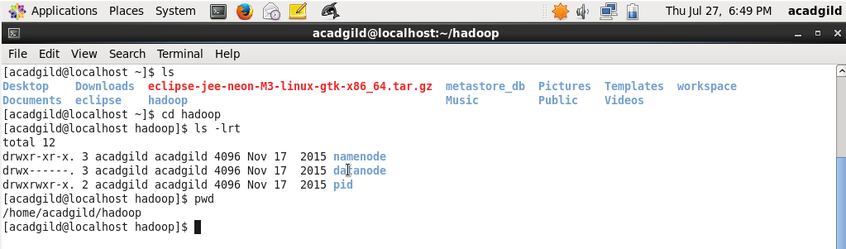

1. vi:- vi is one of the file editor tool in the unix.

**vi filename**

Creates a new file if it already does not exist, otherwise opens an existing file

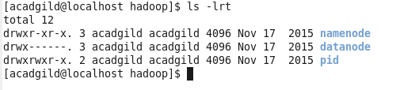



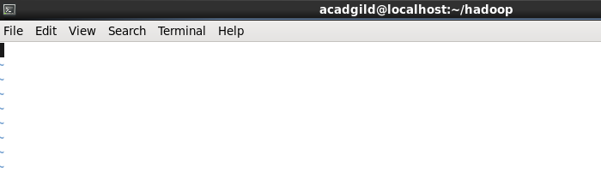

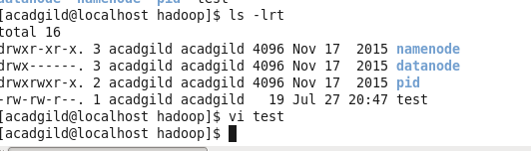

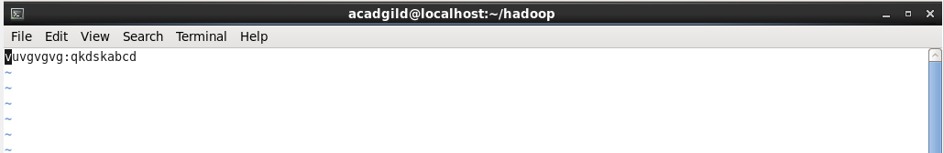

**vi -R filename**

Opens an existing file in the read-only mode.



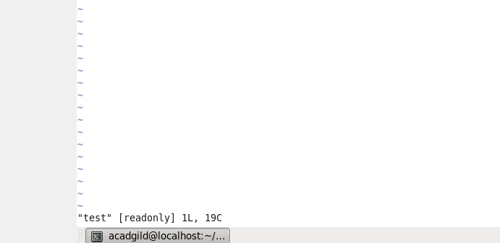

1. Touch:-

-a, change the access time only

-c, if the file does not exist, do not create it

-d, update the access and modification times

-m, change the modification time only

-r, use the access and modification times of file

-t, creates a file using a specified time

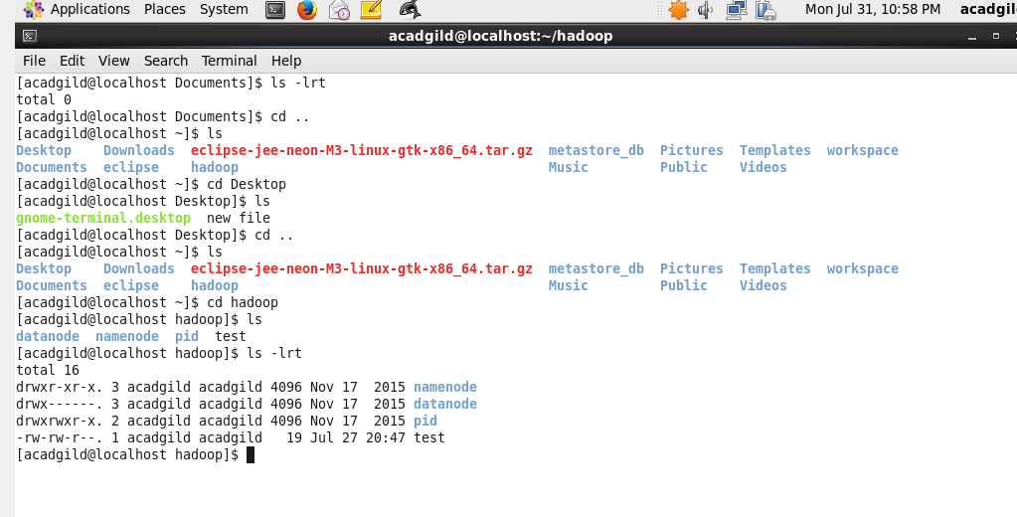

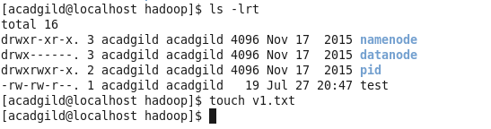

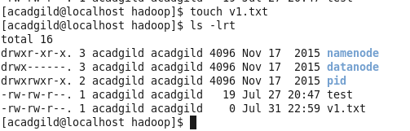



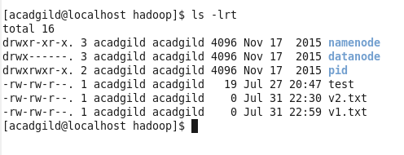

1. Mkdir:- creates Directory

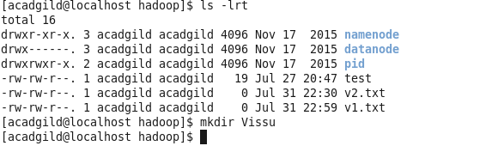

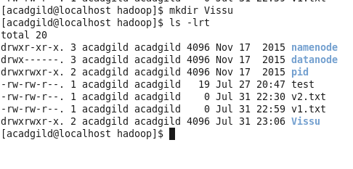

1. Rm :- remove

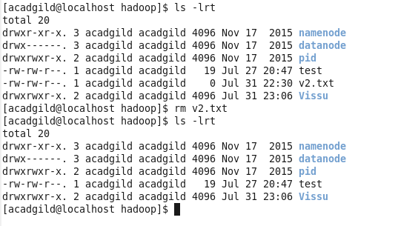

1. ls :- List all the files in the directory

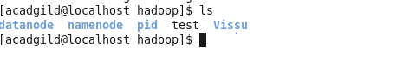

1. echo: echo command displays the give text

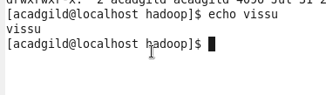

1. cat:



1. who:

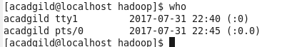

1. cd : to change the directory

pwd is 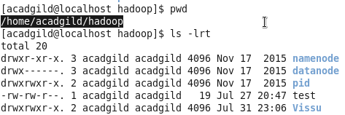

to move to directory Vissu, user can use cd command

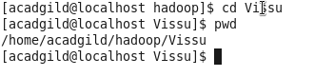

1. date

date is used to view the system date

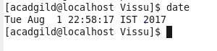

1. cal:

displays the calendar of the month

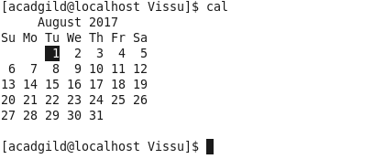

1. mv

move command is used to move a file from one location to another location

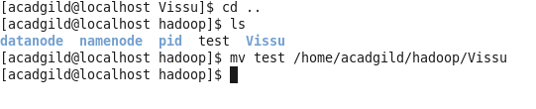

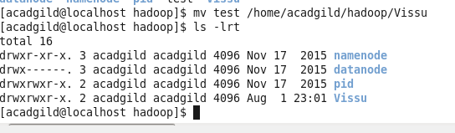

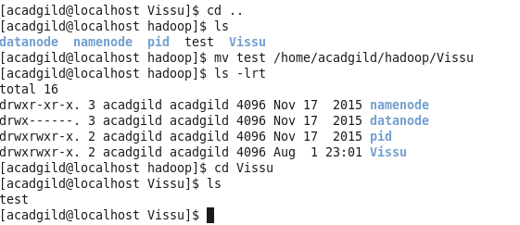

1. cp:

copy command is used to copy the file to a new file

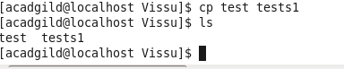

1. which:

which is a **Unix command** used to identify the location of executables



To find the executable file associated with a command name of date